REQUIREMENT ANALYSIS AND PLANNING

Field | Details
Date | 28 June 2026
Team ID | SWTID-2026-9625
Project Name | AI-Enabled Student Admission System
Maximum Marks | 4 Marks

PHASE 1
1. Introduction
The student admission process is one of the most important operations in educational institutions and training organizations. Many institutes still rely on manual methods such as spreadsheets, emails, and paper-based records to manage student information, course registrations, approvals, and communication. These traditional methods often result in data duplication, delayed approvals, poor visibility, security risks, and increased administrative workload.
The AI-Enabled Student Admission System is developed using the Salesforce platform to automate and streamline the complete student admission and support lifecycle. The application centralizes student and course management, automates enrollment and approval processes, provides real-time reporting, and leverages Agentforce AI to assist counselors and administrators in improving productivity and decision-making..

2. Problem Statement
Educational institutions face several challenges while managing student admissions through manual or disconnected systems. Student records are often maintained across multiple spreadsheets or applications, leading to duplicate data, inconsistent information, and difficulty tracking admission progress. Manual approval processes consume significant time, while communication gaps between departments delay student enrollment.
To address these challenges, this project proposes an AI-enabled solution using Salesforce CRM. The system centralizes student and course information, automates workflows, secures data through role-based access, and provides AI-powered assistance for counselors and administrators. This improves operational efficiency, reduces manual effort, enhances transparency, and ensures a smooth admission process.

3. Project Objectives
The main objectives of this project are:
- Automate the complete student admission and enrollment process.
- Centralize student and course information in Salesforce.
- Reduce manual work and eliminate duplicate data.
- Implement automated approval workflows for admissions.
- Apply role-based security to protect sensitive information.
- Generate real-time reports and dashboards for better decision-making.
- Enable AI-powered assistance for counselors and administrators using Agentforce.
- Improve communication, operational efficiency, and the overall student experience.

4. Empathy Map Canvas
An Empathy Map helps identify the needs, expectations, and challenges of students, counselors, and administrators involved in the admission process. It supports the development of a user-friendly, efficient, and AI-enabled admission system.
Empathy Map Summary
Section | Description
Says | "I need a quick, simple, and transparent admission process."
Thinks | Student information, course details, and application status should be available in one place.
Does | Submits admission applications, enrolls in courses, tracks application status, and communicates with counselors.
Feels | Frustrated by manual paperwork, delayed approvals, and lack of application visibility.
Pains | Duplicate records, approval delays, communication gaps, security concerns, and inefficient manual processes.
Gains | Faster admissions, automated approvals, centralized records, AI-assisted support, secure data management, and real-time updates.
Figure 1: Empathy Map Canvas for AI-Enabled Student Admission System.

5. Expected Outcome
The expected outcome of this project is a fully automated AI-Enabled Student Admission System developed on the Salesforce platform using Admin tools and Agentforce without custom Apex development.
The application enables institutions to manage students, courses, enrollments, approvals, communication, and reporting from a centralized platform. Automated workflows simplify the admission process, while role-based security ensures data protection. Agentforce provides AI-powered assistance to counselors and administrators, helping them respond to student queries, reduce manual effort, and make informed decisions.
The solution improves admission efficiency, minimizes administrative workload, enhances data accuracy, increases transparency, and delivers a better experience for both students and institutional staff.

Conclusion
The Phase 1 activities focused on identifying the existing challenges in student admission management, understanding stakeholder requirements, and defining the project's objectives. Through problem analysis and empathy mapping, the need for an AI-enabled, centralized admission management system was established. This phase provides the foundation for the subsequent stages of requirement analysis, system design, Salesforce implementation, automation, testing, and deployment.

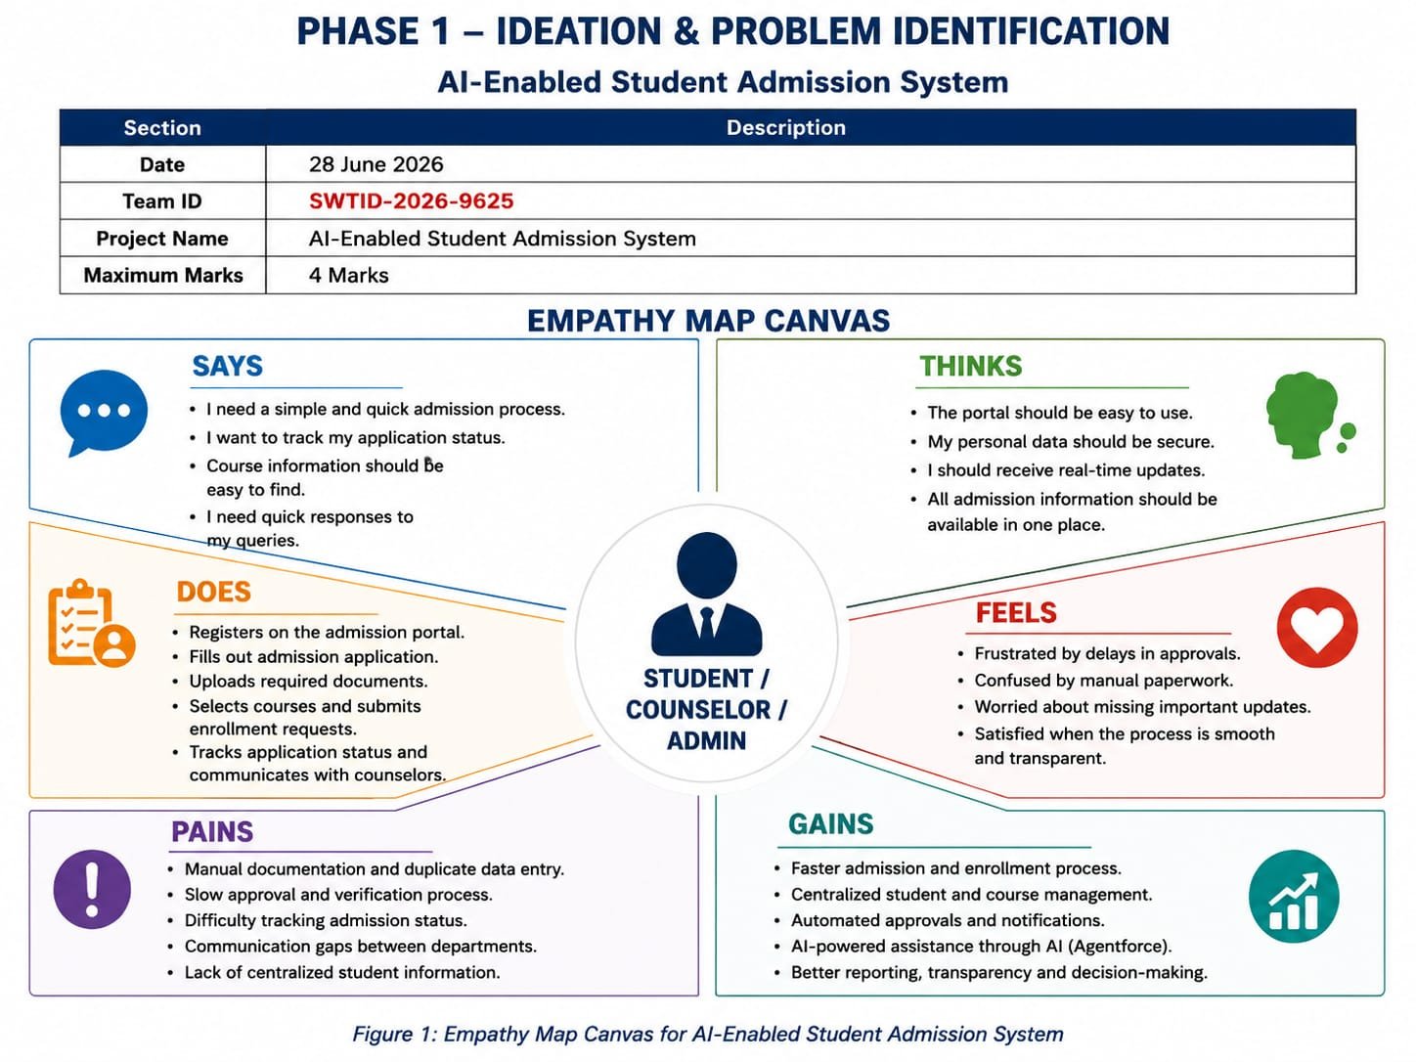
5. Expected Outcome
The expected outcome of this project is a fully automated AI-Enabled Student Admission System developed on the Salesforce platform using Admin tools and Agentforce without custom Apex development.
The application enables institutions to manage students, courses, enrollments, approvals, communication, and reporting from a centralized platform. Automated workflows simplify the admission process, while role-based security ensures data protection. Agentforce provides AI-powered assistance to counselors and administrators, helping them respond to student queries, reduce manual effort, and make informed decisions.
The solution improves admission efficiency, minimizes administrative workload, enhances data accuracy, increases transparency, and delivers a better experience for both students and institutional staff.

Conclusion
The Phase 1 activities focused on identifying the existing challenges in student admission management, understanding stakeholder requirements, and defining the project's objectives. Through problem analysis and empathy mapping, the need for an AI-enabled, centralized admission management system was established. This phase provides the foundation for the subsequent stages of requirement analysis, system design, Salesforce implementation, automation, testing, and deployment.

